CSA 283: Final

Name: ______________________________________ Section: _____ _____

Please write legibly. Ask questions if something is unclear. Write down any assumptions you make.

Exam is printed on both sides of the page!

Keep your answers concise. Write the minimum that is necessary when explaining.

Some useful formulas:
d_{trans} = L/R d_{prop} = d/s

- Consider the network diagram shown in the supplemental handout. The diagram depicts the following:

- Four end systems labeled A, B, C, and D
- Two switches labeled S1 And S2
(Switch interfaces are labeled 1 – 3)
- Four routers labeled R1, R2, R3, R4, and R5.
  - The interfaces of R1 are labeled 1 – 3
  - Router R5 is performing NAT

Information held at various nodes is given in tables on the page following the diagram.

Use the diagram and tables to answer the following questions. Write no more than one sentence when on “Why of Why not?” questions.

- Consider a message being sent from host A to host C and the segments, datagrams, and frames that will be generated to carry the message.
- The socket on A that is being used to send messages has a port number of 80.
- The port number of the socket being used on C to receive the message is 4500.

    - Would the switch labeled S1 have a MAC address? (3 points)

    - Based on the information shown to be held by each host, can A put
together a frame that will be received by R1? Why/ why not? (4 points)

    - If you answered no to the previous question, describe the process that would take place before. (4 points)

    - After the process in the previous question has completed, how would the switch table for S1 be updated? (4 points)

    - Taking into account the results of the previous question, when A is sending a packet to C, will the network interface adapter of B receive the frame that is sent by A to R1? Why or why not? (4 points)

    - Can A transmit a frame to R1 via S1 while R1 is transmitting a frame to B via S1 without colliding? Why or why not? (4 points)

    - When a datagram travels from A to C, what will the source and destination physical addresses be in the frame that carries it from A to R1? (4 points)

Source MAC: ____________________________________

Destination MAC: ____________________________________

    - When A is sending a datagram to C, what will be the destination IP address and port number in the datagram/segment as it travels between A and R1? (4 points)

Destination IP ____________________________________

Destination Port ____________________________________

    - When A is sending a datagram to C, what will be the source IP address and port number in the datagram /segment as it travels between A and R1? (4 points)

Source IP ____________________________________

Source Port ____________________________________

    - Based on the forwarding table given for R1, when A is sending a packet to C, will it forward the packet to R2 or R3? (4 points)

    - Give the Classless InterDomain Routing (CIDR) notation for the firt subnet identified by forwarding table of R2. Indicate approximately how many hosts each sub-net could contain. (4 points)

CIDR notation Approx. Number of Hosts

________________________ __________

    - When a datagram travels from A to C, what will the source and destination physical addresses be in the frame that carries it from R4 to R5? (4 points)

Source MAC: ____________________________________

Destination MAC: ____________________________________

    - Suppose the subnet between R4 and R5 has a MTU of 788 bytes. Further suppose the original datagrams sent by A have a length of 2300 bytes. Fill in the characteristics for the fragments that would be created to carry the data in the datagram with an ID of 22 . Assume the IP header is 20 bytes long for all fragments. (8 points)

Original Datagram:
 | Length = 2300 | ID = 22 | Fragflag = 0 | Offset = 0

Fragments:
 | Length = | ID = | Fragflag = | Offset =

 | Length = | ID = | Fragflag = | Offset =

 | Length = | ID = | Fragflag = | Offset =

 | Length = | ID = | Fragflag = | Offset =

    - When A is sending a datagram to C, what will be the source IP address and port number in the datagram /segment as it travels between R5 and C? (4 points)

Source IP ____________________________________

Source Port ____________________________________

    - When A is sending a datagram to C, what will be the destination IP address and port number in the datagram /segment as it travels between R5 and C? (4 points)

Destination IP ____________________________________

Destination Port ____________________________________

    - When R5 is sending a frame to C, will the interface adapter of D receive the frame? Why/why not? (4 points)

    - After R5 has sent a frame to C, would the switch table for S2 be updated? If so how? (4 points)

    - If C sends a reply back to A, what will the source IP address and source port number be in the datagram/segment as it travels between C and R5? (4 points)

Source IP ____________________________________

Source Port ____________________________________

    - When C sends a reply back to A, what will be the destination IP address and port number in the datagram/segment as it travels between C and R5?
(4 points)

Destination IP ____________________________________

Destination Port ____________________________________

    - Under what circumstances would D use ARP to determine the MAC address of B

- Give definitions for the following terms using one or two sentences. If the term is an acronym, also state what the letters in the acronym stand for and give a definition. Use no more than two sentences to describe the term.

a. Proxy Server (6 points):

b. Non-Persistent Connection (6 points):

c. BGP (6 points):

d. Multiple Access Protocol (6 points)

e. Broadcast (6 points)

- Use the distance vector algorithm to update D’s forwarding table.

Routers are identified by upper case letters i.e. A, B, C, D, E

Subnets (destinations) are identified by lower case letters i.e. s, t, u, v, w, x, y, z.

The neighbors of a router are one hop (one subnet) away.

The following is the routing table at router A:

Destination Subnet | Next Router | Number of Hops to Dest.
s | B | 4
t | C | 3
u | - | 1
v | B | 4
y | C | 5
… | … | …

Assume that router A receives the following advertisement from neighbor B:

Destination Subnet | Next Router | Number of Hops to Dest.
s | R | 7
t | - | 1
u | - | 1
y | Q | 8
z | F | 5

As a result of the above advertisement, A may (or not) change its routing table. Show A’s updated routing table below: (18 points)

Please list the destinations in alphabetical order.

Destination Subnet | Next Router | Number of Hops to Dest.

- Consider the following scenario:

An application running on mailfwd.uc.edu wants to transmit email for larry@npr.org to the mail server for npr.org. In the following, assume that all nodes cache DNS records. All DNS caches are initially empty. The first query sent by mailfwd.uc.edu is handled recursively. Assume all other queries are handled recursively as well. DNS server names are as follows:

TLD DNS server, edu: dns.tld.edu
TLD DNS server, org: dns.tld.org
Local Name server, uc: local.uc.edu
Local Name server, npr: local.npr.org
Authoritative DNS, npr: dns.npr.org
Authoritative DNS, uc: dns.uc.edu
Root DNS server: dns.root
Mail server, uc: mailfwd.uc.edu
Mail server, npr: mailfwd.npr.org

- 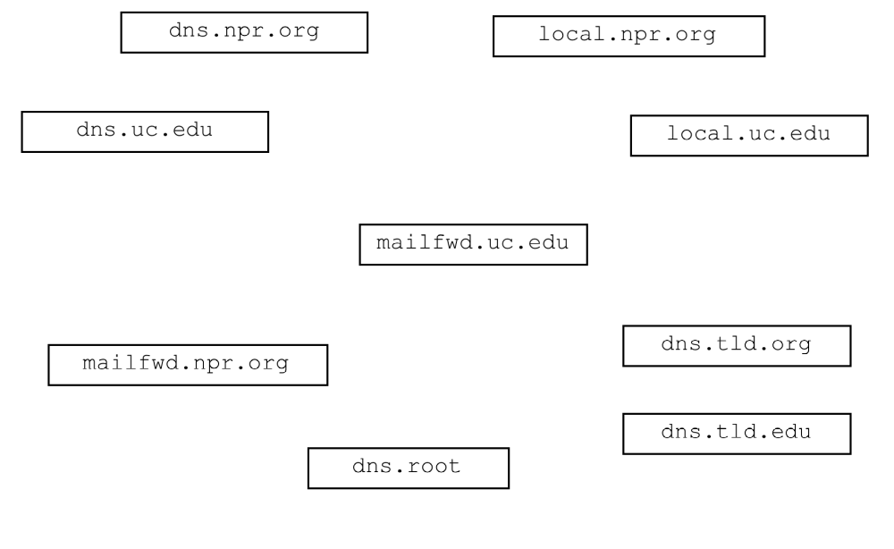Draw arrows labeled with numbers to indicate the order of queries and responses sent before mailfwd.uc.edu receives the IP address of mailfwd.npr.org.
(16 points)

- What type of resource record would initially be sought by mailfwd.uc.edu? (circle one) (3 points)

Type A Type NS Type CNAME Type MX

- What type of resource record would actually contain the IP address of mailfwd.npr.org mail? (circle one) (3 points)

Type A Type NS Type CNAME Type MX

- Assume the sequence in the previous question has just occurred and mailfwd.uc.edu has the IP address for mailfwd.npr.org.

  - What will mailfwd.uc.edu do next? (3 points)

  - What application layer protocol will mailfwd.uc.edu use to transfer the message? (3 points)

_________________

  - What transport layer protocol will mailfwd.uc.edu use? (3 points)

_________________

  - Which machine will be the client? (3 points)

_________________

  - Which machine will be the server? (3 points)

_________________

- Complete the Client below. Do not worry about handling exceptions. Allow the main method to throw them to the OS. (40 points)
- Clients send an unknown number of floats (4 bytes each) to the server in a single datagram using UDP. The maximum number of floats that can be sent in a single datagram is 100.
- The Server determines the number of floats in the datagram and calculates the sum of them and sends the sum back to the client as a double (8 bytes) using UDP. The client then displays the sum.
- The Server listens on port number 7777.
- Client only send one set of numbers and then close down. Close all open streams and sockets before the client exits.

import java.io.*;
import java.net.*;

public class UDPSumClient {

public static void main(String[] args) throws Exception
{
- Complete the Server class on the following page. Do not worry about handling exceptions. Allow the main method to throw them to the OS. (40 points)
- The Server handles clients sequentially (no multi-threading).
- Clients send an unknown number of floats (4 bytes each) to the server using TCP. The end of the floats is indicated by a value of zero.
- The Server calculates the sum of the floats and sends the sum back to the client as a double using TCP.
- After serving one client, the server again waits for a connection from another client. After serving ten clients, the server closes down.
- The Server listens on port number 7777.
- Close all open streams and sockets before the program exits.

import java.io.*;
import java.net.*;

public class TCPSumServer {

public static void main(String[] args) throws Exception
{

